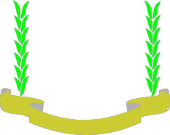

JARAMOGI OGINGA ODINGA UNIVERSITY OF SCIENCE AND TECHNOLOGY
DIVISION OF ACADEMIC, STUDENT AFFAIRS AND RESEARCH
JOOUST VLIR-IUC Programme Support Unit

P.O. BOX 210 - 40601
BONDO
www.jooust.ac.ke

Date: 20th September, 2025

To Whom It May Concern,
I am pleased to recommend Nichodemus Werre Amollo for admission to the MPhil in Population Health Sciences at the University of Cambridge. I had the privilege of supervising Nichodemus during his role as Research Data Management Analyst in the JOOUST–VLIR-UOS SP3 Initiative, where he was responsible for designing monitoring systems and managing large health datasets across Kenya, Uganda, and Tanzania.
Nichodemus consistently demonstrated advanced statistical and data management skills, applying rigorous methods in survey design, sampling, and analysis. His ability to integrate epidemiological approaches with applied econometrics was particularly impressive and showed academic maturity beyond his training. He also provided technical training to research teams, reflecting strong leadership and communication abilities.
I am confident that Nichodemus has the academic excellence, research experience, and intellectual curiosity to thrive at Cambridge. I strongly support his application without reservation.

Best regards,
Japheth Ogol
Lecturer/Senior Researcher, JOOUST + VLIR-UOS Project
japheth.ogol@ejooust.ac.ke



